CSCE 310 Database Systems

Homework 4

Raymond Zhu

923008555

Problem 1:

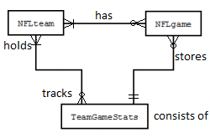

Problem 2:

The value of the expression $π_{hd}(PC)$ as a set is all the unique values contained in the projection. The values are as follows:

**select distinct (hd) from pc;**

**[250, 80, 320, 200, 300, 160]**

The value of the expression as a bag is all of the values contained in the projection. The values are as follows:

**select hd from pc;**

**[250, 250, 80, 250, 250, 320, 200, 250, 250, 300, 160, 160, 80]**

Taking the sum of each list and calculating we get

Average value of the list as a set: **218.33**

**ij> select avg (distinct hd) from pc;**

**1**

**----------**

**218**

Average value of the list as a bag: **215.38**

**ij> select avg (hd) from pc;**

**1**

**----------**

**215**

Problem 3:

Given the two relations:

R (A, B): {(0,1), (2,3), (0,1), (2,4), (3,4)}

S (B, C): {(0,1), (2,4), (2,5), (3,4), (0,2), (3,4)}

Compute $π_{B+1, C-1}(S)$: Select tuples B and C by B+1 and B-1

**{(1,0), (3,3), (3,4), (4,3), (1,1), (4,3)}**

Compute $τ_{B,C}(S)$: Order by B and then C

**{(0,1), (0,2), (2,4), (2,5), (3,4), (3,4)}**

Compute $δ(S)$: Getting all distinct tuples

**{(0,1), (2,4), (2,5), (0,2), (3,4)}**

Problem 4:

Find the distinct manufacturers of printers.

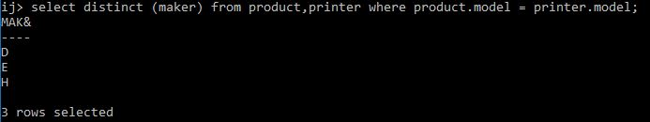

Find the model number, memory size, and screen size for laptops costing less than $1500

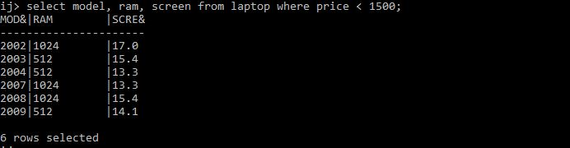

Find all the rows in the printer table for color printers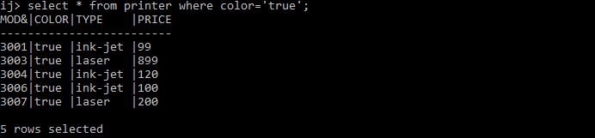

Problem 5:

Find the class name and country for all classes with 8 guns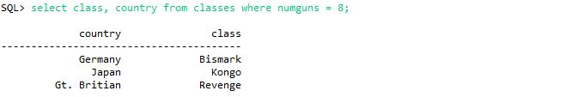

Find the names of the ships sunk in battle and the name of the battle in which they were sunk

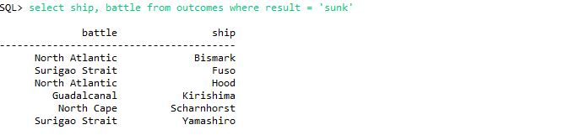

Find all ships that begin with the letter “R”

**select * from ships where name like ‘R%’;**

Problem 6:

Find the model number, price, and type of all products (any type) made by manufacture “D”

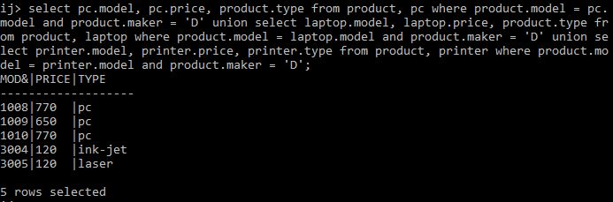

Find the hard disk sizes that occur in two or more laptops

Problem 7:

Find the ships heavier than 35,000 tons

**select name from ships where class (select class from classes where displacement > 35000)**

List all the ships mentioned in the database

**select ship from sys. tables**

Problem 8:

Find the printers with the highest price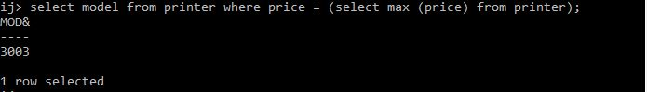

Find the model number of the highest priced item in the database

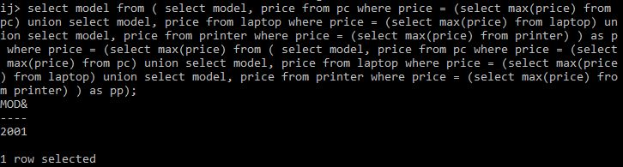

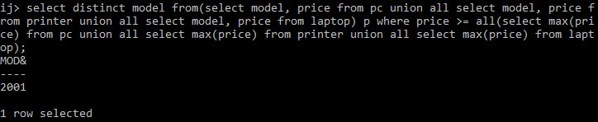

Problem 9:

Find the countries whose ships had the largest number of guns

**select C.country from classes C where numGuns >= all (select numGuns from classes);**

**select C.country from classes C where numGuns in (select max(numGuns) from classes);**

Find the battles in which ships of the Kongo class participated

**select O.battle from Outcomes O where O.ship in (select S.name from Ships S where S.class = ‘Kongo’);**

**select distinct O.battle from Outcomes O where O.ship = any (select S.name from Ships S where S.class = ‘Kongo’);**

Problem 10:

Find the average speed of PCs



Find, for each different type, the average price of a printer

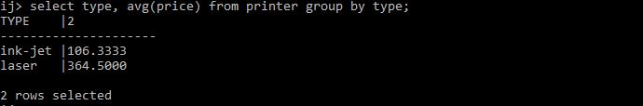

Problem 11:

Find the average number of guns of battleship classes

**select class, avg(numGuns) from classes group by class**

Find for each class the number of ships of that class sunk in battle

**select S.class, count(O.ship) from ships S, (select * from Outcomes where result = ‘sunk’) O where S.name = O.ship group by S.class;**

An Aggie does not lie, cheat, steal, or tolerate those who do.